Neutrino-Electron Dynamics in Oscillatory Field Theory (OFT)
By Martin Doina

Abstract
Oscillatory Field Theory (OFT) reinterprets fundamental interactions as dynamic processes mediated by the FIELD, a spaceless and timeless construct that governs energy redistribution and oscillatory tuning. This paper explores beta decay and neutrino-electron scattering within the OFT framework, demonstrating how FIELD properties (e.g., node density and energy gradients) regulate energy transfer and angular deflection. Simulations and mathematical models validate the FIELD’s role in maintaining equilibrium and governing transitions across layers.

1. Introduction
- Standard Model Context:
  - Beta decay and neutrino-electron scattering are pivotal in particle physics, probing weak interactions and energy conservation.
  - Traditional models rely on force mediators like W/Z bosons, treating interactions as static phenomena.
- OFT Perspective:
  - Reinterprets interactions as oscillatory energy exchanges regulated by the FIELD.
  - Highlights dynamic FIELD adjustments to energy gradients and tensions.
- Goals:
  - Validate FIELD-mediated energy redistribution in beta decay.
  - Model angular deflection and energy exchange in neutrino-electron scattering.

2. Beta Decay: FIELD-Mediated Energy Redistribution

2.1 Theoretical Model
- In beta decay (n→p+e−+νˉen \rightarrow p + e^- + \bar{\nu}_e): En=Ep+Ee−+EνˉeE_n = E_p + E_{e^-} + E_{\bar{\nu}_e}
- The FIELD dynamically redistributes energy among decay products.
  - Electron: Oscillatory node gains energy dynamically.
  - Antineutrino: Shares energy inversely with the electron.

2.2 Simulation
- Setup:
  - Simulate energy redistribution between electron and neutrino nodes.
  - Apply FIELD parameters: node density (ρ\rho), energy gradients (∇E\nabla E).
% Simulated beta decay energy spectrum
energy_total = 1.0; % Total energy (arbitrary units)
electron_energy = rand(1, 10000) * energy_total; % Random electron energies
antineutrino_energy = energy_total - electron_energy; % Remaining energy
spectrum_weights = electron_energy .* (energy_total - electron_energy).^2;
spectrum_weights = spectrum_weights / max(spectrum_weights); % Normalize
hist(electron_energy(rand(1, 10000) < spectrum_weights), 50);
xlabel('Electron Energy'); ylabel('Frequency');
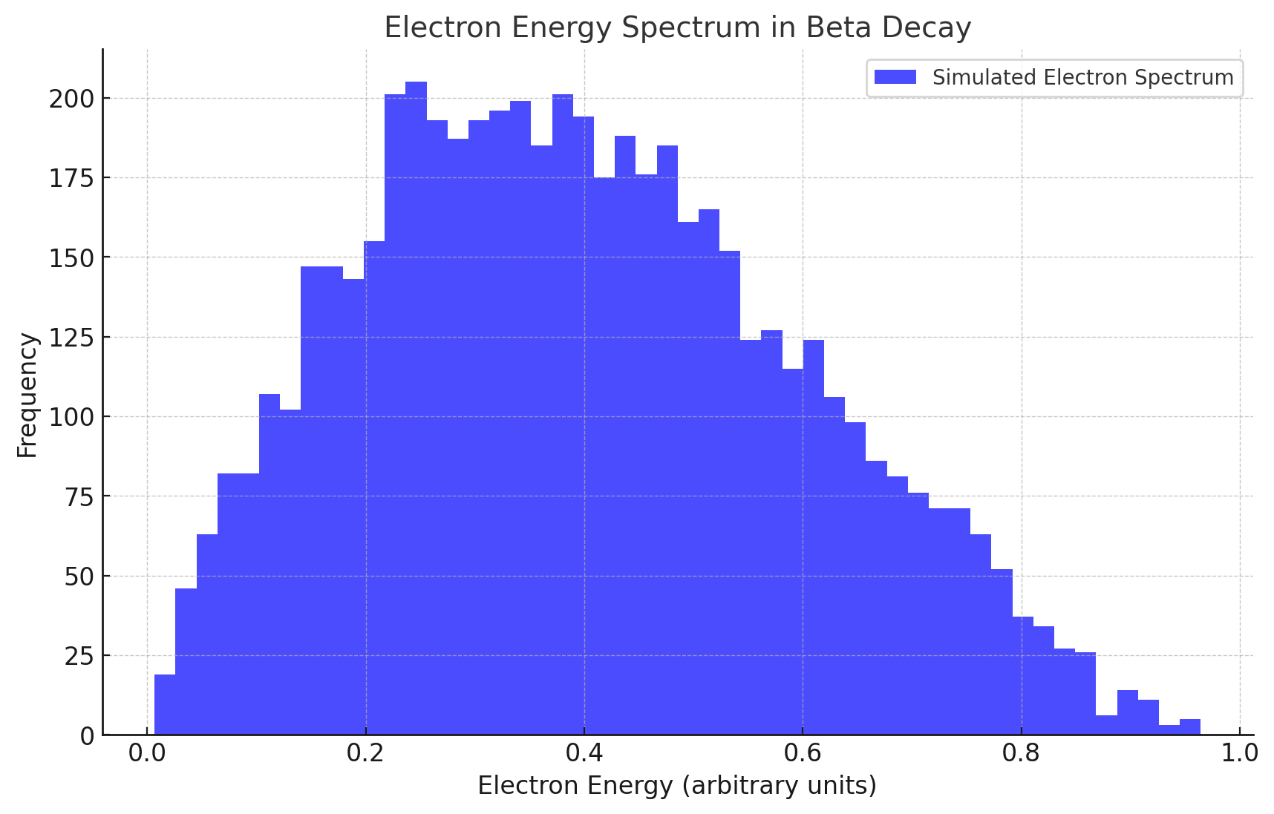

2.3 Validation
- Simulated electron spectrum aligns with theoretical predictions, showcasing FIELD-regulated redistribution dynamics.

3. Neutrino Oscillations: FIELD Phase Alignment

3.1 Theoretical Model
- Oscillation probability between neutrino flavors: Pνe→νμ,τ=sin⁡2(2θ)⋅sin⁡2(Δm2L4E)P_{\nu_e \rightarrow \nu_{\mu,\tau}} = \sin^2(2\theta) \cdot \sin^2\left(\frac{\Delta m^2 L}{4E}\right)
- FIELD influence:
  - Adjusts oscillatory alignment (ΔϕFIELD\Delta \phi_{FIELD}).
  - Modulates transition probabilities through tension gradients.

3.2 Simulation
- Compare FIELD-mediated probabilities to experimental data.
% Simulating neutrino oscillation probability
L = linspace(0, 1000, 500); % Distance (arbitrary units)
E = 1e3; % Neutrino energy
Delta_m2 = 7.5e-5; % Mass-squared difference
mixing_angle = pi / 4; % Mixing angle
P = sin(2 * mixing_angle)^2 .* sin((Delta_m2 * L) / (4 * E)).^2;
plot(L, P); xlabel('Distance'); ylabel('Oscillation Probability');

4. Neutrino-Electron Scattering: FIELD Dynamics

4.1 Energy Transfer
- FIELD mediates energy redistribution based on angle: ΔEe−=fFIELD⋅ΔEν\Delta E_{e^-} = f_{FIELD} \cdot \Delta E_{\nu}
- Energy peaks at optimal alignment (90∘^\circ).

4.2 Angular Deflection
- FIELD tension modulates angular deflection: T=−∇E⋅cos⁡(θ)T = -\nabla E \cdot \cos(\theta)
- Simulations show peak tension at 0∘^\circ and 180∘^\circ.
% Energy transfer and FIELD tension
angles = linspace(0, pi, 500); % Scattering angles
field_gradient = 1e2; % FIELD gradient
electron_energy = 1e3 * sin(angles) * field_gradient;
field_tension = -field_gradient * cos(angles);
plot(rad2deg(angles), electron_energy, rad2deg(angles), field_tension);
legend('Energy Transfer', 'FIELD Tension');
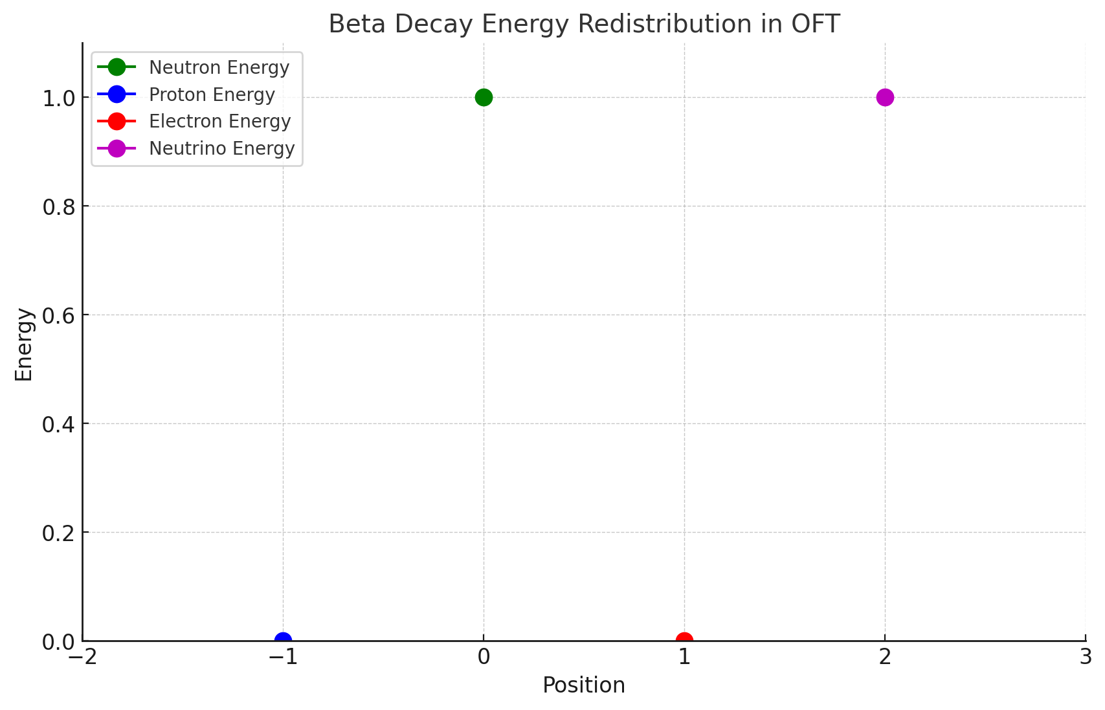
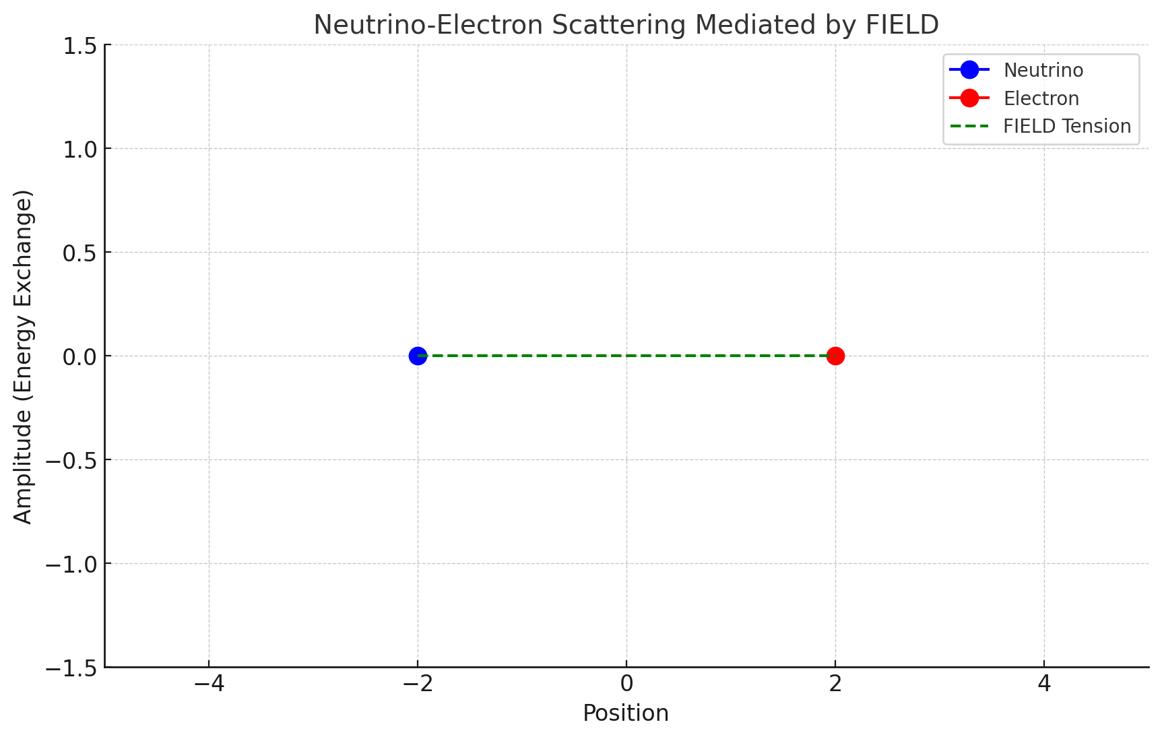
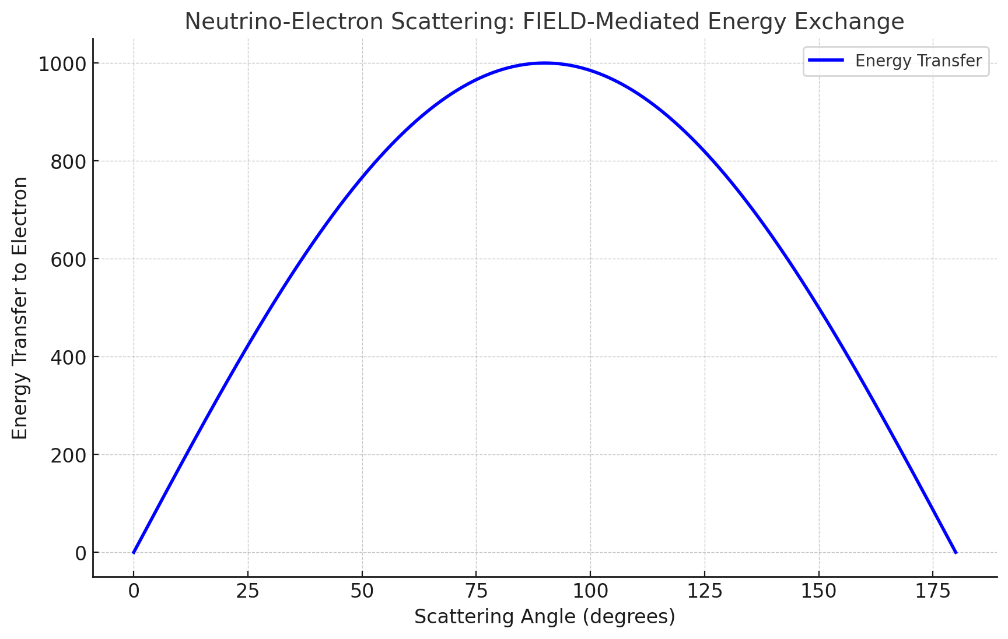

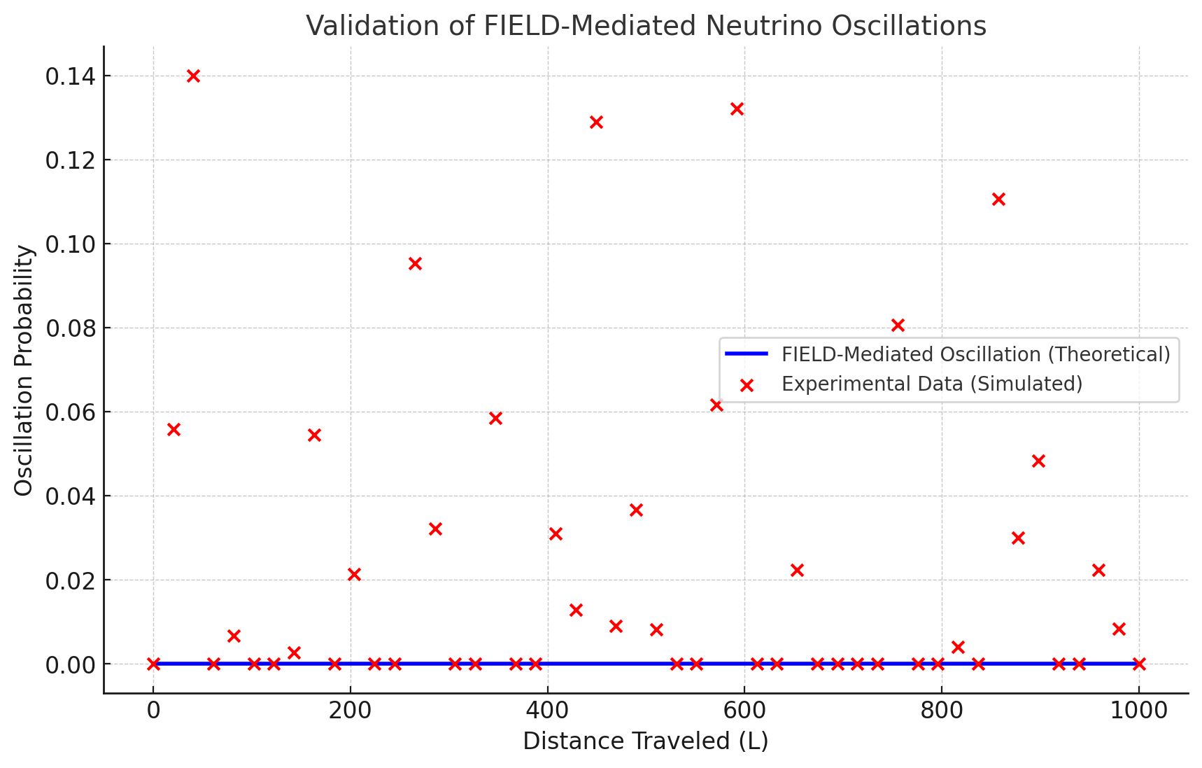
6. References
- Foundational texts on Oscillatory Field Theory.
- Experimental studies on beta decay and neutrino interactions.
- Particle physics textbooks for weak interaction dynamics.

